CS 255 System Design Document Template
This template lays out all the different sections that you need to complete for Project Two. Each section has guidance to prompt your thinking. You will need to continually reference the interview transcript as you work to make sure that you are addressing your client’s needs. There is no required length for the final document. Instead the goal is to complete each section based on what your client’s needs are. Remove this note when you are finished, and replace all bracketed text with the relevant information.
UML Diagrams
UML Use Case Diagram

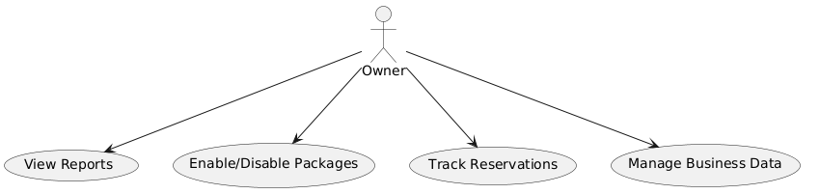

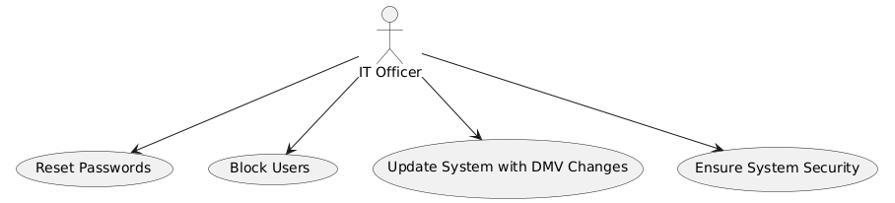
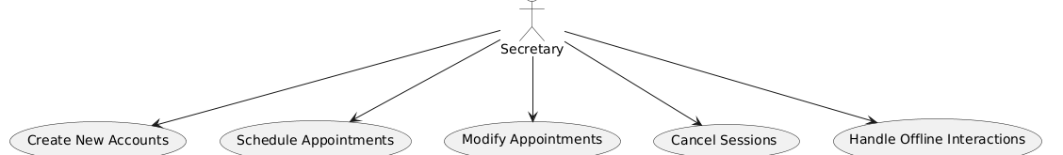

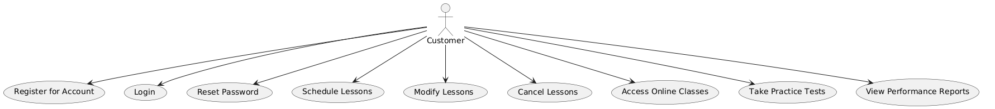

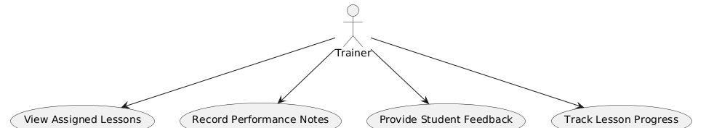
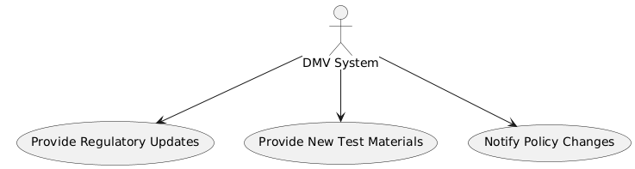

UML Activity Diagrams
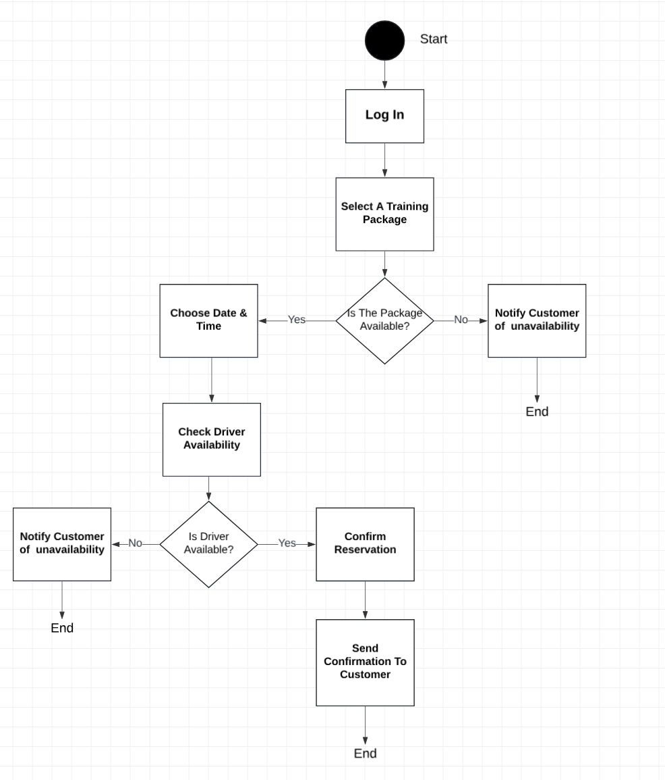

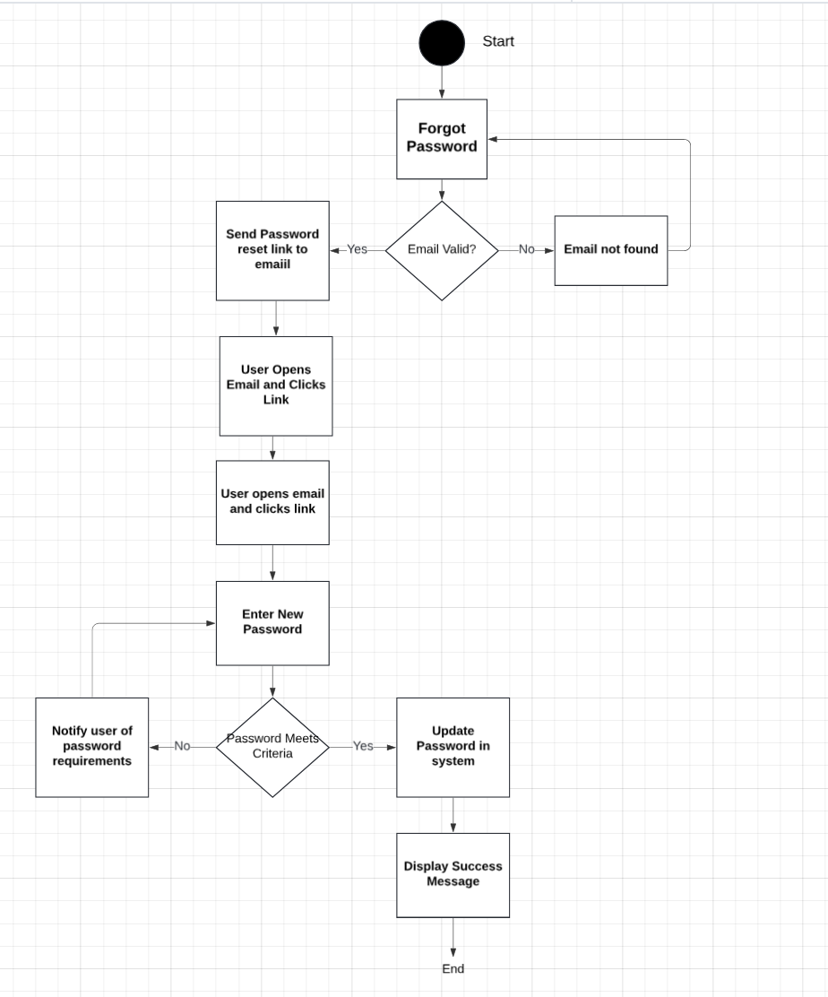

UML Sequence Diagram
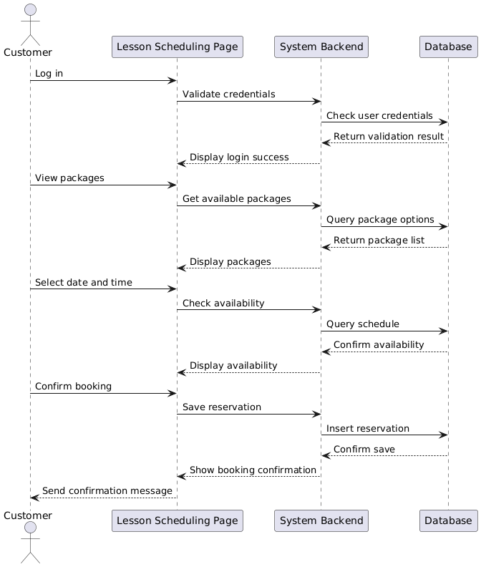

UML Class Diagram

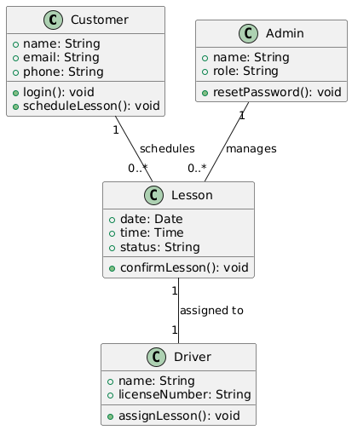

Technical Requirements

The DriverPass system requires a robust technical foundation to support its functionality and ensure a seamless experience for all users. On the hardware side, the system will rely on cloud-based hosting services such as AWS or Google Cloud to provide scalability and high availability. The server infrastructure should include a minimum configuration of an 8-core CPU, 16GB of RAM, and 500GB of scalable SSD storage. Backup servers are essential to ensure redundancy and disaster recovery. End users, including customers and staff, will access the system using standard internet-enabled desktop, laptop, and mobile devices.
For the software, the frontend will be built as a responsive web application using modern frameworks like React.js or Angular, ensuring compatibility across browsers such as Chrome, Safari, and Edge. The design will be mobile-friendly to facilitate use on a variety of devices. The backend will be developed using Node.js or Python (Django/Flask), allowing for efficient server-side processing and integration with the DMV system for real-time updates on regulations and test materials. A PostgreSQL database will be implemented to manage structured data, with real-time synchronization to maintain consistency across sessions and logs. The system will also utilize third-party services, such as email integration for automated password resets and notifications, and payment gateway services if package purchases are required.
Development and maintenance of the system will utilize tools such as VS Code or JetBrains IDEs for coding, Git for version control, and diagramming tools like Lucidchart or PlantUML for creating and refining use case diagrams, class diagrams, and process flows. Monitoring tools like AWS CloudWatch will be used to track system performance and uptime. Hosting infrastructure will include a Content Delivery Network (CDN) to ensure fast load times for users across different locations, along with SSL certificates to secure all connections.
The system’s design emphasizes scalability, incorporating autoscaling capabilities to handle peak loads during high-demand periods. Data integrity and security will be maintained through daily database backups stored securely in the cloud, ensuring data recovery in case of an issue. Strong security measures are integral to the system, including password-protected logins with Two-Factor Authentication (2FA) and automated account locking after five failed login attempts to prevent brute-force attacks. Sensitive user data, such as passwords and credit card details, will be encrypted, and regular security audits will identify and address vulnerabilities. Role-specific access controls will be implemented to limit user permissions based on their roles, ensuring that sensitive data and critical functions are accessible only to authorized personnel.

